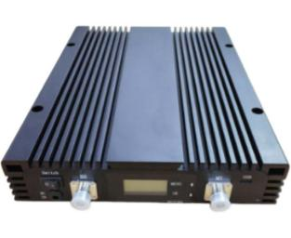
Digital 800/900/1800/2100/2600MHz Band-adjustable Repeater
Model: AT-012-LGDWF-20

Product Features:
- Digital bandwidth-adjustable features allow for seamless adaptability to different frequency bands.
- LCD display the input/output signal strength.
- Auto isolation detection.
- Improve any three mobile networks at the same time.
- Built-in Auto Gain Control (AGC)& Auto Level Control (ALC).
- Center frequency movable.
- OMS Lite for remote/local control and monitoring(Optional)

Working Schematic Diagram
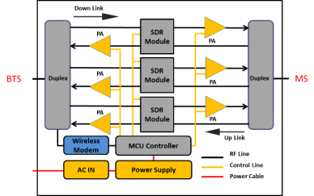

Application Scenario:
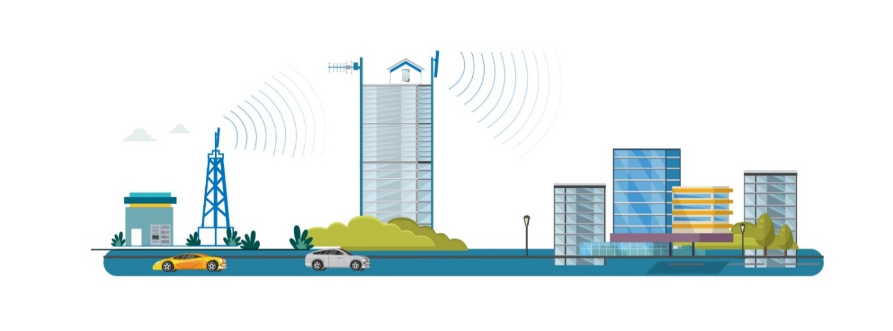

Technical Specifications:
P/N: AT-012-LGDWF-20 |  | B20 | B8 | B3 | B1 | B7
Frequency Range  (MHz,adjustable) | Uplink | 832-862 | 880-915 | 1710-1785 | 1920-1980 | 2500-2570
Frequency Range  (MHz,adjustable) | Downlink | 791-821 | 925-960 | 1805-1880 | 2110-2170 | 2620-2690
Number of Sub-bands |  | 1 | 1 | 1 | 1 | 1
Bandwidthper Sub-band(MHz,adjustable) |  | 0.2-20 | 0.2-20 | 0.2-20 | 0.2-20 | 0.2-20
Max.Gain(dB) | Uplink | 65±2 dB | 65±2 dB | 65±2 dB | 65±2 dB | 65±2 dB
Max.Gain(dB) | Downlink | 70±2 dB | 70±2 dB | 70±2 dB | 70±2 dB | 70±2 dB
Manual Gain Control |  | 31 dB in step of 1dB
Automatic Gain Control |  | ≥20 dB
Gain Flatness(per sub-band) |  | ≤±2.5 dB(peak-to-peak)
Max.Input Power Without Damage |  | 0 dBm
Output Power(dBm) | Uplink | 10±2 | 10±2 | 10±2 | 10±2 | 10±2 | 10±2
Output Power(dBm) | Downlink | 20±2 | 20±2 | 20±2 | 20±2 | 20±2 | 20±2
Out of Band Gain |  | 2.5≤f_offset_CW<5.0 MHz ≤60 dB
 |  | 5.0≤f_offset_CW<10.0 MHz ≤45 dB
 |  | 10.0 MHz≤f_offset_CW ≤35 dB
Spurious Emission | 9KHz-1GHz | ≤-36dBm
Spurious Emission | 1GHz-12.75GHz | ≤-30dBm
ACRR | ±10/20MHz | ≤-36dBc/30KHz
ACRR | ±20/40MHz | ≤-40dBc/30KHz
EVM |  | ≤8% | ≤8% | ≤8% | ≤8% | ≤8% | ≤8%
Frequency Stability |  | ≤±0.01 ppm
Noise Figure |  | ≤6dB
VSWR |  | ≤1.8
System Delay |  | ≤6μs
RF Connector |  | N-Female
Impedance |  | 50Ω
Power Supply |  | Input:AC100~240V,50/60 Hz;Output:DC24V/4.2A
Power Consumption |  | ≤130W
Dimensions |  | 350*268*58mm
Weight |  | ≤12kgs
IP Rating |  | IP30
Operating Temperature |  | -10℃ to60℃
NMS | Local | Via Type-C/Wi-Fi App
NMS | Remote | Via Cloud-based NMS(optional)

Technical specification is subject to change without prior notice.

